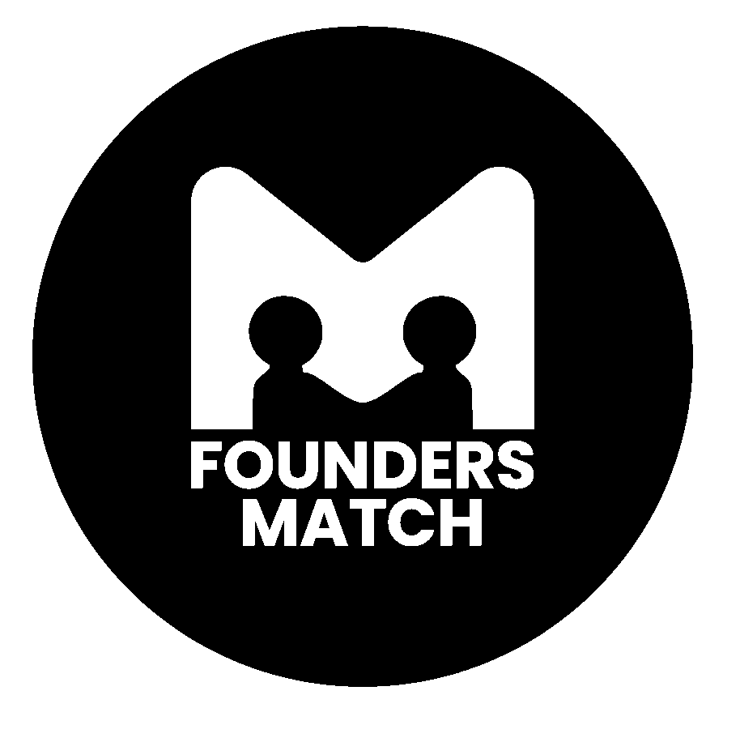

Concept Note: FoundersMatch
1. Introduction FoundersMatch is an initiative under the Ilorin Innovation Hub designed to foster connections between aspiring entrepreneurs and potential co-founders, team members, and partners. This networking event seeks to bridge the gap between innovative ideas and the talent necessary to bring them to life. By providing a curated platform that aligns common interests, experiences, and industries, FoundersMatch aims to catalyze the formation of strong, synergistic startup teams in Kwara State and beyond.
2. Objectives
- Facilitate Meaningful Connections. Create a structured environment where aspiring founders can meet like-minded individuals who share their vision or complement their skills.
- Promote Collaboration. Encourage partnerships across different sectors, experiences, and backgrounds to foster diverse and innovative startup teams.
- Support the Local Startup Ecosystem. Strengthen the entrepreneurial ecosystem in and around Kwara State by enabling the creation of more startups through better team formation.
- Inspire Innovation. Provide a platform that sparks creativity and innovation by bringing together individuals with unique perspectives and skill sets.
- Facilitate Capacity Building. Enhance the skills and knowledge of newly formed teams through targeted capacity building programs that support the growth and sustainability of startups.
3. Key Components
- Curated Networking: Participants will be pre-matched based on shared interests, industry focus, and complementary skills, ensuring that every interaction is meaningful and relevant.
- Interactive Sessions: The event will include icebreaker activities, pitch sessions, and speed networking to encourage participants to showcase their ideas and connect with others.
- Mentorship and Guidance: Experienced entrepreneurs and industry experts will be present to provide guidance and advice, helping participants navigate the complexities of starting a business.
- Capacity Building Programs: After the initial networking event, the Ilorin Innovation Hub will offer workshops, training sessions, and mentoring programs to equip newly formed teams with the skills and knowledge necessary to grow and succeed. These programs will cover essential topics such as business development, marketing, fundraising, and team dynamics.
- Follow-Up Support: After the event, participants will have access to resources and continued networking opportunities through the Ilorin Innovation Hub to further develop the connections made during the event.
4. Target Audience
- Aspiring entrepreneurs looking for co-founders, team members, or partners.
- Early-stage startup founders seeking to expand their teams.
- Professionals and students with expertise in various fields (e.g., tech, marketing, finance) interested in joining or founding a startup.
- Investors and mentors looking to support emerging startups.
5. Expected Outcomes
- Formation of new startup teams with diverse skill sets.
- Strengthened networks within the entrepreneurial ecosystem in Ilorin and Kwara State.
- Increased collaboration and partnership opportunities among participants.
- Enhanced skills and knowledge of participants through capacity building programs, leading to more sustainable and successful startups.
- Successful launch of new ventures driven by the connections made at the event.
6. Timeline
- Pre-Event: Registration and curation of participant profiles.
- Event Day: Networking sessions, pitch presentations, and mentorship opportunities.
- Post-Event: Capacity building programs and continued support through the Ilorin Innovation Hub.
7. Conclusion FoundersMatch represents a significant opportunity to nurture the next wave of successful startups in Kwara State by bringing together talented individuals with a shared passion for innovation. By fostering meaningful connections, facilitating capacity building, and encouraging collaborations, the initiative will contribute to the growth of a vibrant and dynamic entrepreneurial ecosystem in the region.

2-Hour Event Outline: FoundersMatch Maiden Edition
Event Duration: 2 Hours
Objective: Facilitate meaningful connections between aspiring founders and potential team members, encourage collaboration, and kickstart the formation of startup teams.

0:00 - 0:15 | Welcome & Introduction
- Activity: Opening Remarks
  - Facilitator: MD Ilorin Innovation Hub
  - Content: Brief overview of the event’s objectives, introduction to the Ilorin Innovation Hub, and explanation of the event format.
  - Goal: Set the stage for the event, clarify the goals of FoundersMatch, and create an engaging atmosphere.
0:15 - 0:30 | Icebreaker Activity
- Activity: “Founder Bingo”
  - Instructions: Participants receive bingo cards with prompts related to startup experience, skills, or industries (e.g., “Has launched a startup,” “Has expertise in digital marketing”). They must find others in the room who match these prompts and get them to sign their cards.
  - Goal: Break the ice, encourage participants to interact with multiple people quickly, and help identify common interests or complementary skills.
0:30 - 0:45 | Pitch Introduction Round
- Activity: 60-Second Pitches
  - Instructions: Participants introduce themselves and their startup ideas or skills in 60 seconds. Each pitch should include what they are looking for in a co-founder or team member.
  - Goal: Allow participants to present their ideas or skills concisely and make their needs known to the group, setting the stage for targeted networking.
0:45 - 1:15 | Speed Networking
- Activity: Rotating 5-Minute Conversations
  - Instructions: Participants are paired up for 5-minute conversations. A bell rings to signal the end of each session, and participants move to a new partner. This process is repeated for multiple rounds.
  - Goal: Maximize the number of meaningful connections made, ensuring that participants have the opportunity to speak with many potential partners or team members.
1:15 - 1:30 | Break
- Activity: Networking Over Light Refreshments
  - Instructions: Participants take a short break to relax and continue conversations from the speed networking session in a more informal setting.
  - Goal: Provide time for participants to follow up with those they connected with during speed networking.
1:30 - 1:50 | Group Formation & Mentorship
- Activity: Guided Group Discussions
  - Instructions: Participants who found potential matches during the networking sessions form small groups (3-5 people) and discuss their ideas further. Mentors from the Ilorin Innovation Hub circulate to offer advice and answer questions.
  - Goal: Facilitate deeper discussions and the initial steps of team formation, while providing mentorship to guide the process.
1:50 - 2:00 | Closing Remarks & Next Steps
- Activity: Wrap-Up and Call to Action
  - Facilitator: IHS Representative
  - Content: Recap key points from the event, provide information on post-event resources and follow-up activities (e.g., capacity building programs), and encourage participants to continue networking and collaborating.
  - Goal: Reinforce the connections made during the event and ensure participants know how to access further support and opportunities.

